Navigating to Payroll Reports (and saving them to favorites)-
Click on Tableau from the http://my.rutgers.edu or from http://bireporting.rutgers.edu-
Click on Explore and then Finance-
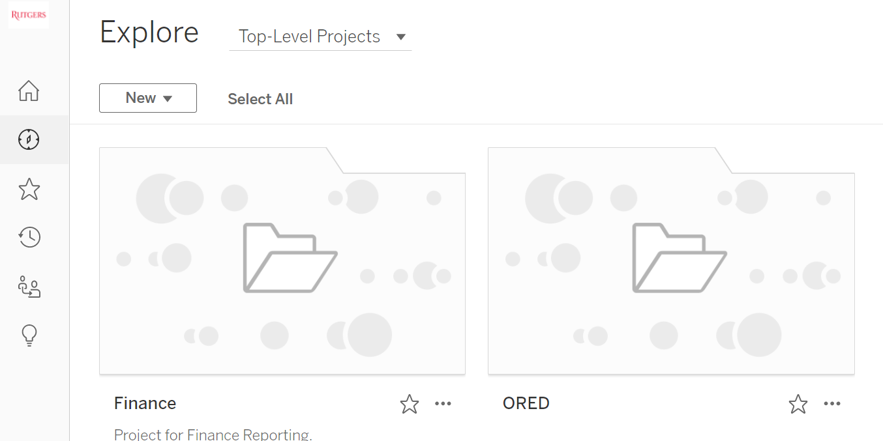
Click on Finance, then Manage Reporting and then Payroll-
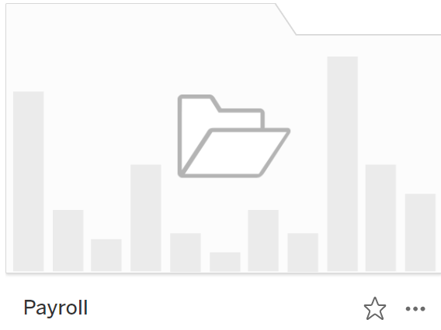

This will give you all the payroll options-
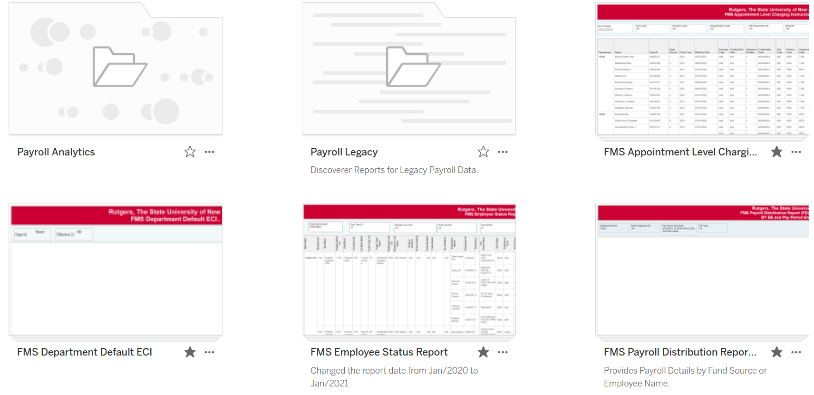
When you find reports you like, click on the star icon-
Star icon-
Once you click on the star, when you log onto tableau, your favorite reports will appear on home page-
