Non Cost Labor Adjustment Approvals-
On May 5, 2019, Cornerstone announce for the Non Cost Labor Adjustments approval function is now working. All transactions need to have a separate preparer and approver.
The creation of the non-cost labor adjustments procedure has not changed, the procedure for the approving has changed.
Approvers- you should have your preparer contact you whenever they are processing these transfers so you are aware of that the entry is ready for approval.
https://my.rutgers.edu
Click on:
Click on Projects and then Costs:
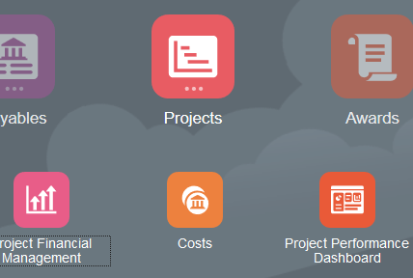
Costs
Projects
Click on the task icon to open up the menu:
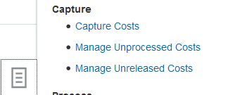
Click on Manage Unreleased Costs

This will open “Manage Unreleased Costs” screen:
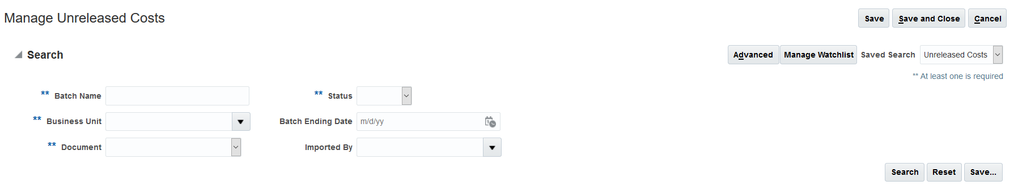
In “Business Unit” select “Rutgers BU”
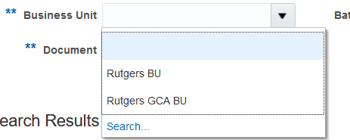
In “Imported By” click on the “down arrow” and click on “search”
Enter the net id or the person’s name who prepared (imported) the non-cost labor adjustment
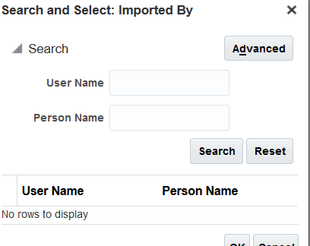
Select your preparer and then click on “Search”
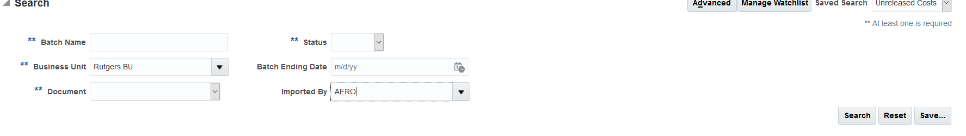
This will bring up open items to “release”

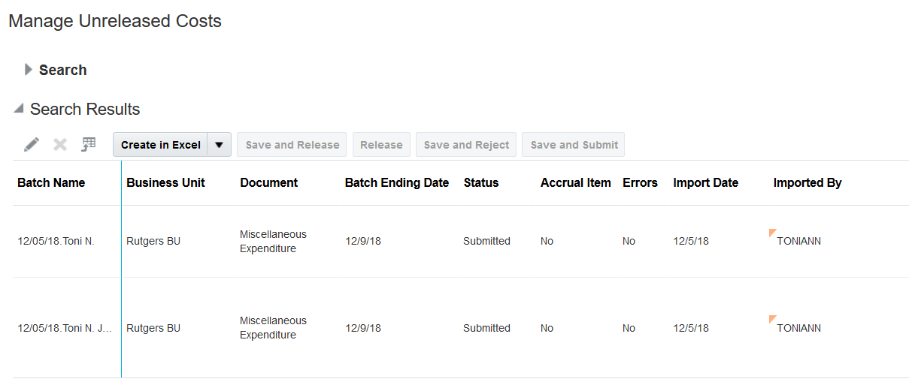
You will be allowed to “release” (approve) the transaction or “reject” the transaction from here. Once you process that, the non-cost labor adjustment will post.

