Project Costs Adjustments Quick Guide
- Use the Nonlabor Costs for Third-Party Applications spreadsheet to create a project cost adjustment and have the ADFDI Plugin enabled on your computer (ADFDI Installation Job Aid).

- Complete the header section fields:
  - Business Unit = Rutgers BU
  - Source = RU Project Transactions
  - Document = Depending on the entry you are trying to create:
    - 01 - Project to Project Cost Transfer
    - 02 - Project and GL Cost Transfer
NOTE: Document Options noted as for RFS Use Only are for Research Financial Services use only. If a Preparer uses these options in error, the entry will be auto rejected.
  - Expenditure Batch = Give your journal a unique name. Do Not reuse a previous name.
- Complete the line section fields:
  - Document Entry = Copy what was previously entered in the Document field (either 01 - Project to Project Cost Transfer or 02 - Project and GL Cost Transfer)
  - Expenditure Item Date = today’s date unless there are other fiscal periods open and you trying to get the entry into a prior fiscal year period
  - Project Number
  - Task Number
  - Expenditure Type = Account segment
  - Expenditure Organization = UDO (Unit, Division, Organization) for the project
  - Quantity = dollars to be transferred (positive quantity debits project, negative quantity credits project)
  - Original Transaction Reference = Organization segment for the project
  - Unmatched Negative Item = Yes (only if the Preparer entered a negative quantity)
  - Expenditure Comments = Enter comments to explain the reason for the adjustment. Include your NetID for reference to make it easier to identify who completed the entry
  - Transaction Currency = USD
- Project and GL Cost Adjustment is a one-line entry
  - Raw Cost Debit Account Field = Leave blank
  - Raw Cost Credit Account Field = The GL string is only needed for the GL side of the project to GL cost adjustment or the GL to project cost adjustment.
- Project to Project Cost Adjustment is a two-line entry
  - Raw Cost Debit Account Field = Leave blank on both lines
  - Raw Cost Credit Account Field = Leave blank on both lines
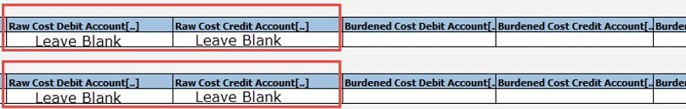
- After exporting the spreadsheet, be sure to attach supporting documentation and submit the entry to a finance approver in the Financial Management System. Save a copy of the submitted spreadsheet for your records.
August 2023 project costs adjustments videos and job aids link – canvas.rutgers.edu

