Report 023-
Report 023 will allow you to see your GL (General Ledger) string activity in the month that it hits. Cornerstone is a system that shows totals. There is no report currently that will give you an ending balance/beginning balance- but report 023 will allow to at least see the activity in the month.
Log onto https://my.rutgers.edu
Click on: 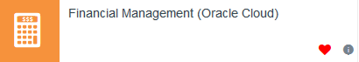
Click on: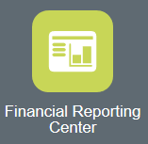
This will open up the Financial Reporting Center.
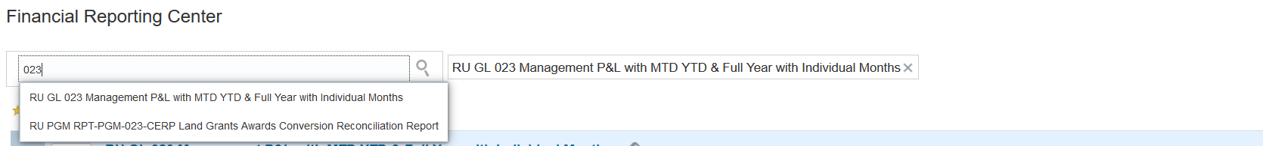
Enter the report number 023 in the search bar. The report will pop up, click on “RU GL 023 Management P&L with MTD YTD & Full Year with Individual Months”
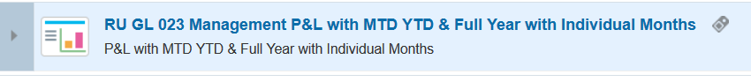
Click on report name to open the parameters
You should have point of preview set up and allow pop up to get to the parameter view for the reports.
Once you enter in the parameters, Cornerstone will keep those parameters in the system, so if you look at subsequent months, all you have to do is update the accounting period.
Also- please note, since the GL string for your area warehouses the entire operation, you should utilize the GL string that you use for your operating expenses.

Point of View:
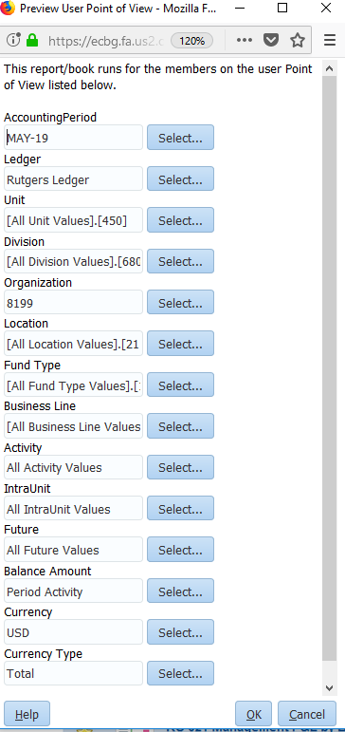
Select the Business Line (what you use for your operation expenses)
Select Total
Select USD
Select Period Activity
Select All Future Values
Select All IntraUnit Values
Select All Activity Values
Select the Fund Type (what you use for your operation expenses)
Select the Location (2110)
Month and Year of the Accounting Period
Select the Organization
Select the Division
Select your Unit (450)
Select Rutgers Ledger
Once you select your parameters and click ok, you will be prompted to select the start of the fiscal year.
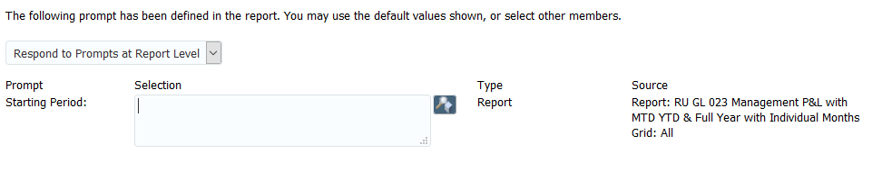
Enter in the start of the fiscal year- example “JUL-19” and click on OK to run your report:
This will open the report up in the GGP or Great Grand Parent Level
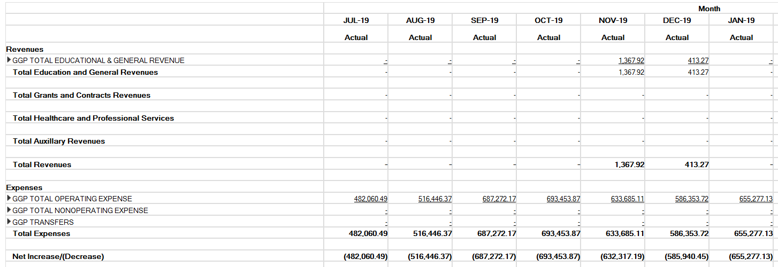
Expenses is where you would need to look for your expenses per month. To do so, you will need to open up the report by clicking on the arrow icon next to the GGP name.
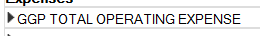
Click on the arrow to expand the report
This will open up to the GP or Grand Parent level, you will need to click the arrow to open to the P or Parent level, then you will need to click on the arrow to open up the child level (or operation level)
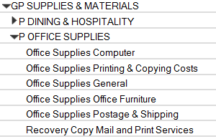
This will show you the total purchases per month in each activity category

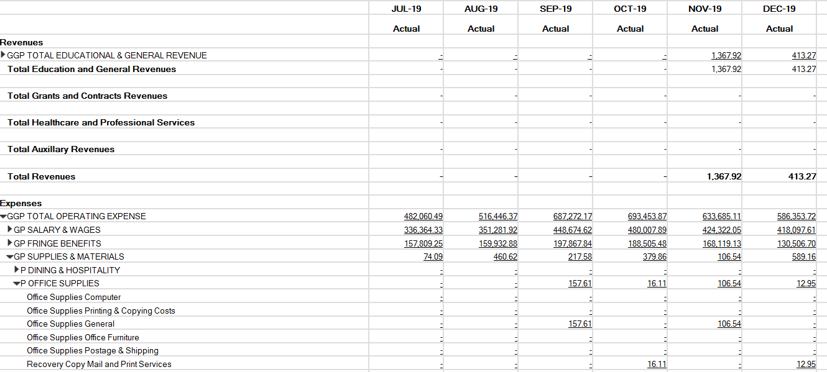
The operational or child level has no letter next to the activity category.
The Child Level, will roll up to the Parent level, which will roll up to the Grand Parent Level. In the above example, $157.61 was purchased in “Office Supplies General” in the month of September. This dollar amount also appears in the “P Office Supplies” (which is why it appears twice). That $157.61 will also be part of the $217.58 that appears in the GP Supplies and Materials which will contain all the purchases for that month that occurred in the Supplies and Materials Activity codes.
If you need to see details of that monthly purchase, click on the dollar amount 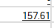
This will open up options to get into the detail, click on “Drill to Detail Balances”
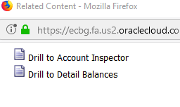

This will show the search screen:
This will automatically be prefilled with the account activity code selected
This will automatically be prefilled for the month you select
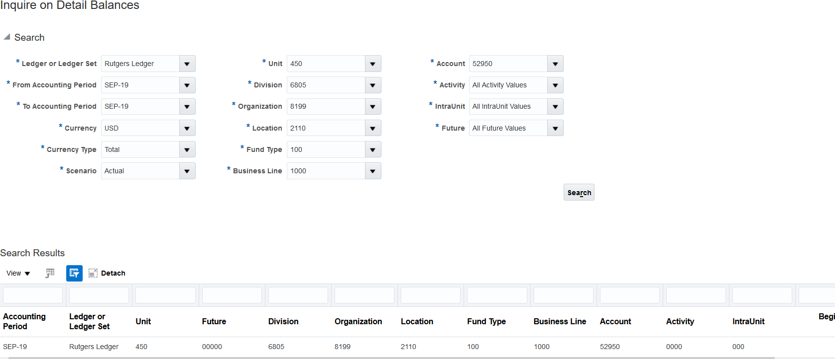
Scroll to the right to get to the “Period Activity”
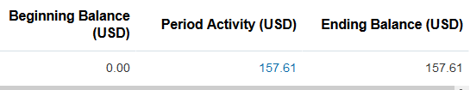
Click on the dollar amount to get into the detail
Click on the dollar amount to see the actual entry
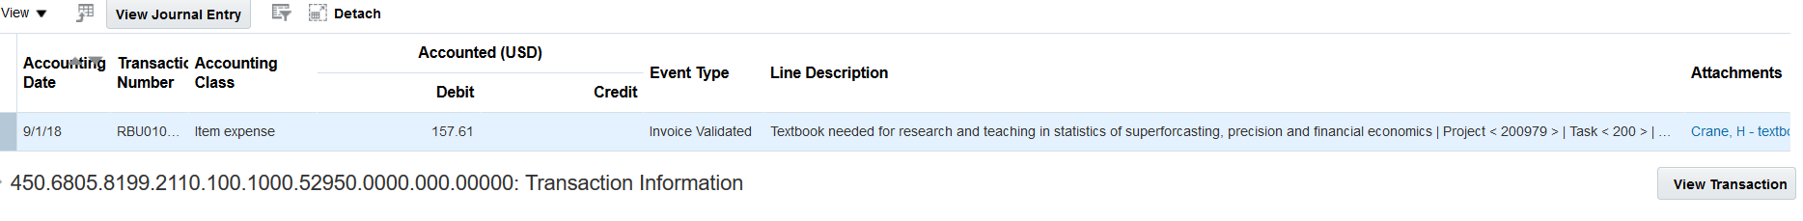
Click on “View Transaction” to see the actual purchase order. (This works for purchase orders and reimbursements)

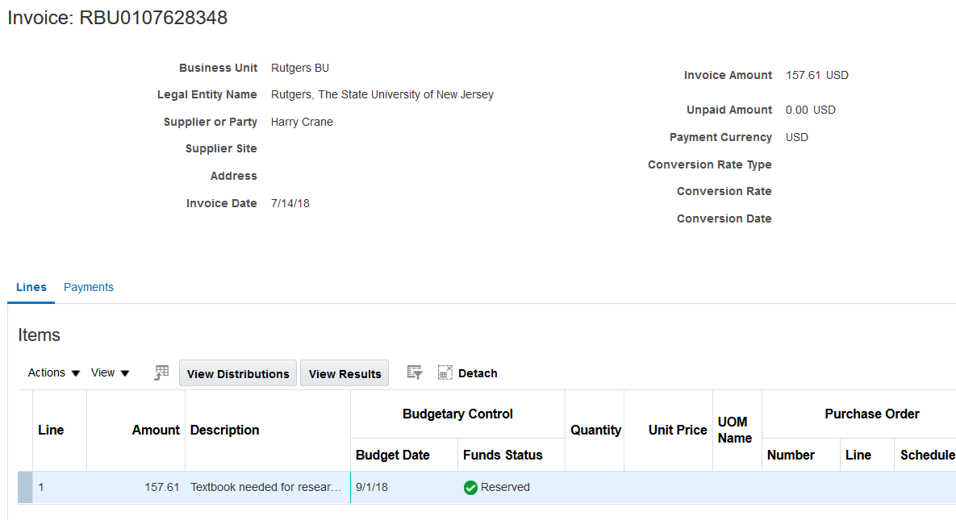
While you are in the “Inquire on Detail Balances” screen, you can change the account value to “All Account Values” and click on search, it will bring up all the account activity codes for that month.
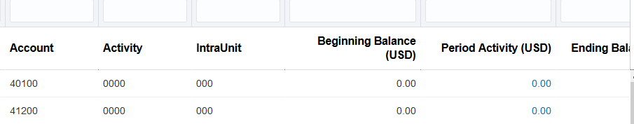
You can export this section to excel by click on to see all the period activity for the month. By downloading the file to excel, you can delete the lines with no activity.
