SAS Guide on how to Run the FMS Employee Status Report Export List-
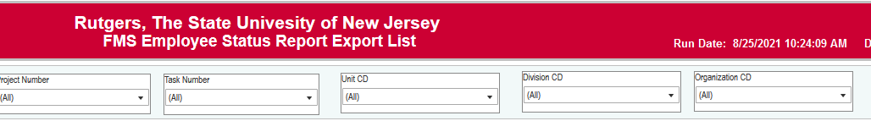
Before entering any data, pause your report to enter you search criteria by clicking on the “pause” icon on the top of the screen. .
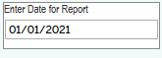The End Date for Report will show you who is paid against your strings as of that date. For the fall semester, please use a fall date where all your PTLs and TAs are on payroll. For the spring semester, please use a spring date where all your PTLs and TAs are on payroll.
Fund type code should remain as “All”.
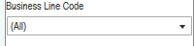Business line can be changed to see specific segments of the string- example: if you want to see your fellows, change your business line to 6820. If you want to see all of your employees, you should leave the business line code as “All”.
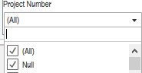You can enter a specific project number(s) here that you would like to see. If you keep Project Number as “All” the report will return all the projects with the associated GL string you enter. If you change the Project Number to “Null” the report WILL NOT RETURN any projects.
Task number should remain as all to bring in all associated task numbers (if applicable) of where people are being paid.
Unit code is the code for the unit (should be 450).
Division code is the code for your organization. If you have multiple division codes you can enter in more than one.
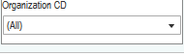Organization code is the code for your organization. If you have multiple organization codes you can enter in more than one.
When you have your search criteria selected, click on resume:
This will run your report-
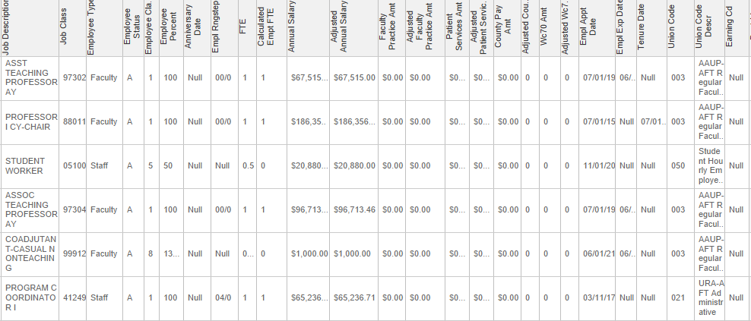

To export it to excel- click on download:
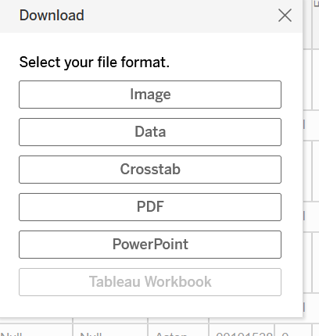
Click on Crosstab
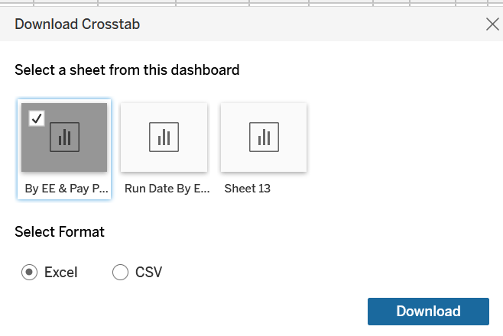
You can click on for the report to run in Excel or CSV
Excel will keep the format as it appears in the report. CSV will run the report in excel, it will have the information on every line (it is a little easier to run a pivot table that way).

