SAS Guide on how to Run the FMS Employee Status Report by Employee
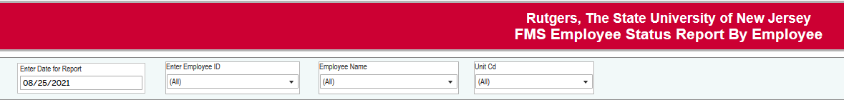
Before entering any data, pause your report to enter you search criteria by clicking on the “pause” icon on the top of the screen. .
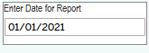 Enter the date that you want to see where the employee was paid.
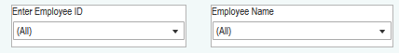You can enter the Employee ID OR Employee Name (YOU DO NOT NEED TO ENTER THE BOTH).
You do not need both. When you have your search criteria selected, click on resume:
This will run your report-
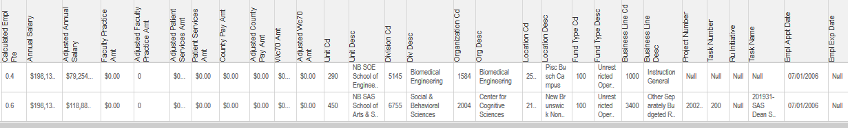
To export it to excel- click on download:
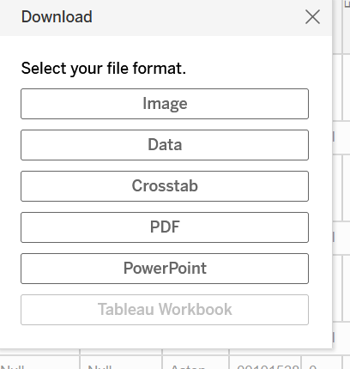
Click on Crosstab
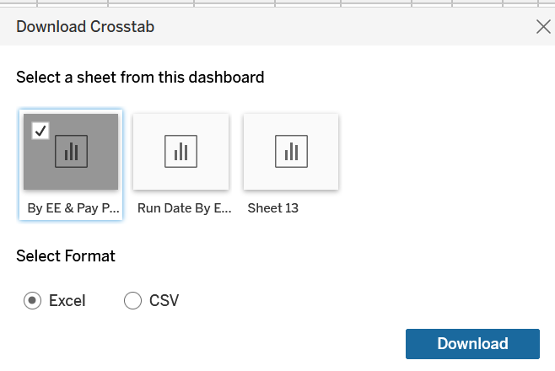
You can click on for the report to run in Excel or CSV
Excel will keep the format as it appears in the report. CSV will run the report in excel, it will have the information on every line (it is a little easier to run a pivot table that way).

