SAS Guide on how to run the FMS Payroll Distribution Report by Employee & Date Range (Detail)-
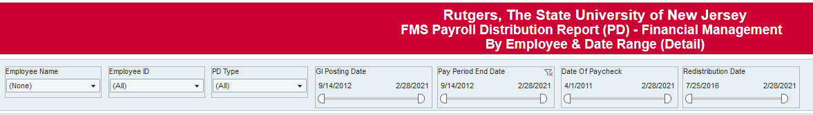
Before entering any data, pause your report to enter you search criteria by clicking on the “pause” icon on the top of the screen. .
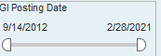GL Posting Date will bring back the date that the payroll entry hit for the person you are searching for, the pay period end date, date of paycheck, and redistribution date.
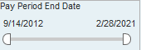Pay Period End Date is the weekly payroll date, this is Friday for both salaried and hourly employees. The pay week alternates for salaried and hourly employees.
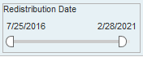Redistribution Date is the date a salary reallocation was processed, this can be done through Employee Charging Instructions or the Salary and Wage Redistribution and Justification (SWRJ) application.
You can enter in either the Employee’s name or Employee’s ID number 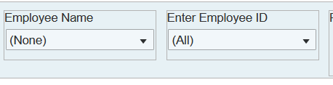
You do not need both. When you have your search criteria selected, click on resume:
This will run your report-
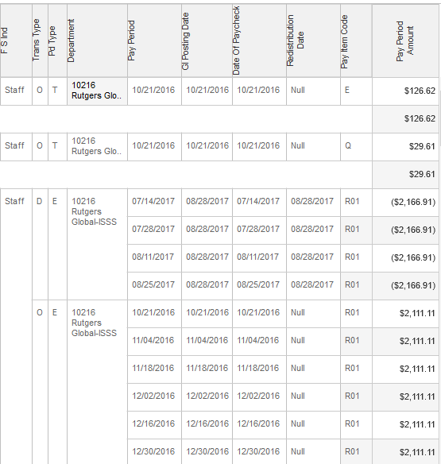
To export it to excel- click on download:
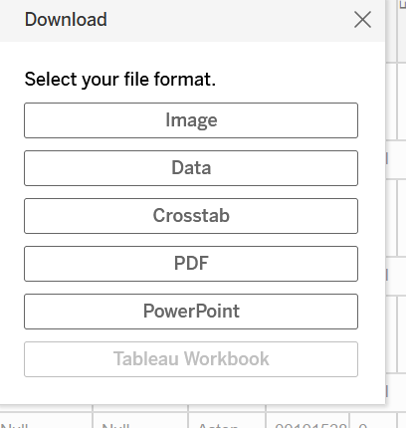
Click on Crosstab
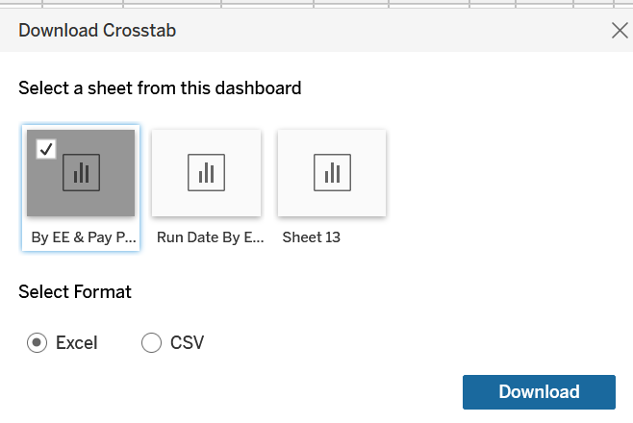
You can click on for the report to run in Excel or CSV
Excel will keep the format as it appears in the report. CSV will run the report in excel, it will have the information on every line (it is a little easier to run a pivot table that way).

