To run Report 073-
Click on the following path: Financial Management Oracle Cloud Tools Reports and Analytics All Folders Shared Folders Custom RU Custom Reports PGM Reports RU PJ Project Costs Detail Report

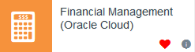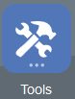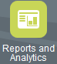
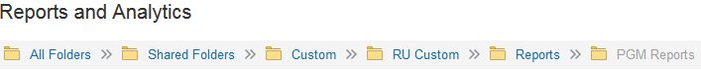
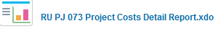
This will open up your search criteria.
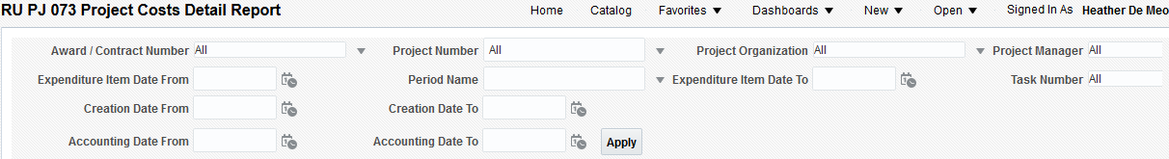
You will need to enter in your project number and select your accounting dates. By selecting the accounting dates, you will be able to see items when they hit the ledger.
Run the report by “Accounting Date” to see when it hits the ledger
To select your project, click on the drop down menu, remove the “”sign next to the “all”
Select your dates, and then click on “Apply” 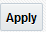
When the report is finished running, it will open in excel-
Raw Cost is the expenses
